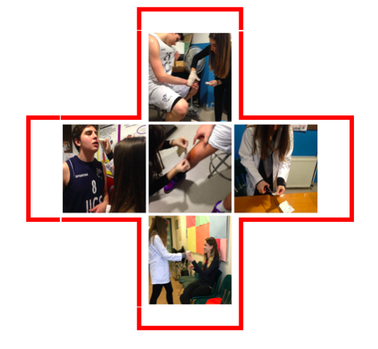

**Goal:** To prepare the IICS community in the practice of First Aid.

**Inquiry Question:** How can First Aid be brought and prioritized by the IICS community?

From an early age I have been fascinated by the workings of life. The human body is a remarkable machine with many diverse systems producing an organism that could never be artificially reproduced. My love of science is just one of my reasons for choosing medicine as a topic. This is what drives me to work on improving and focusing on First Aid, a part derived from my fascination for the world continuing to be healed one person at a time.

It is shocking to say that, a quarter, which is 24% of people would not do anything during a moment of emergency because they do not know what to do, and only wait for the ambulance to get to the situation. Looking at IICS, only about 5 to 7 teachers/staff not including the nurse have received and have a creditable first aid training certificate that is in use of right now. This number is surprisingly low when compared to the large student body. My goal is to make first aid an essential criterion at IICS. With the completion of a Basic First Aid and Adult/Child Infant CPR course, I will be able to put my knowledge into action with demonstrations. At the same time, the production of series of video documentaries will visually demonstrate the different segments that make up essential areas of First Aid. Specifically aimed at staff and students who are going on class trips, or participating in sports events.

**“Thousands of people are dying** each year in situations where first aid could have made the difference. This includes nearly **900 people who choke** to death, **2,500 who asphyxiate** from a blocked airway and **29,000 who die from heart attacks**.” (St John Ambulance)

**First Aid at IICS**